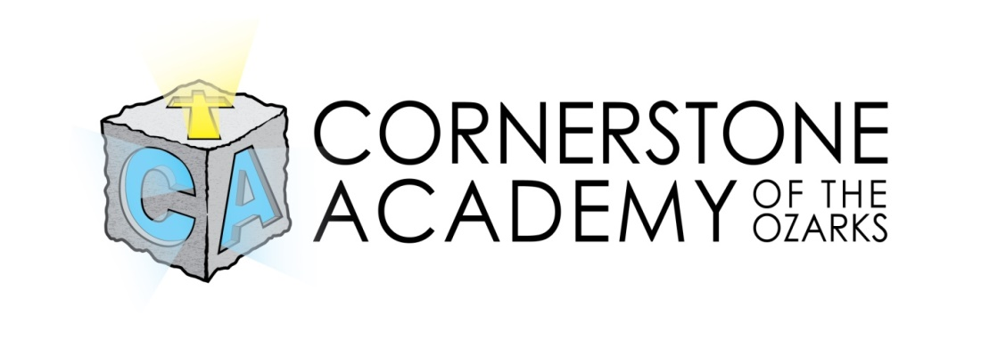

2021-2022 School Calendar

August 26: Meet the Teacher/Pre-K & Elementary Orientation
September 1: First Day of School
September 6: No School/Labor Day
October 16 No School/Professional Development for staff (subject to change, pending the conference date)
October 22: No School
October 29: No School
October 15: End of 1st Quarter (Professional Development for teachers) /No school/Jr. High & High school may have assignments for home
Nov. 23-26: Thanksgiving Break/No School
December 10: No School
December 22: End of 2nd Quarter/Half Day Dismiss at Noon
Dec.21-Jan 3: Christmas Break/No School
January 5: School Resumes
January 12: Parent Teacher Conferences (before or after school/schedule with techers)
January 17: Martin Luther King Day/No School
February 4: No School/PD Day/Jr. High & High School may have assignments for home
February 21: Presidents Day/ No School
March 9: End of 3rd Quarter
March 10-14: No School/Spring Break
April 15-18: No School/Resurrection Celebration Break
May 13: Pre-K & Kindergarten Graduation/Last Day of School/End of 4th Quarter

First Friday of each month will be curriculum alignment for teachers to collaborate for accreditation team. Classes will remain in session and lessons will be prepared by classroom teachers and carried out by a substitute on these days to allow for collaboration.

September: on campus: 12 days January: on campus: 11 days May: 3 on campus 9 days off campus: 8 days 2 off
Total: 20 days Total: 19 days Total: 5
October: on campus: 10 days February: on campus: 10 days
off campus: 9 days off campus: 8 days
Total: 19 days Total: 18 days
November: on campus: 8 days March: on campus: 12 days Totals:
off campus: 7 Days off campus: 9 days 84 days on
Total: 15 days Total: 21 days 67 days off
December: on campus: 7 days April: on campus:11 days 151 days
off campus: 6 off campus 9 days
Total: 13 days Total: 20 days

